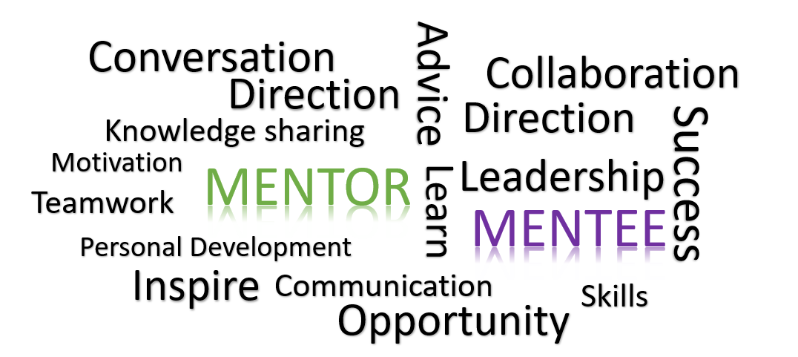 | RBMS Mentoring Program  Guide to Mentoring for RBMS members  River Basin Management Society

RBMS Mentoring Program Guide
Most people throughout the course of their life and career can reflect upon and note the various individuals along the way that were important to their growth and development, personally and professionally. These mentoring relationships have helped that person to find a purpose, define a goal or shape their thinking and establish an outcome (if project related). Mentoring can serve many purposes by helping an individual develop a new skill, assist with problem solving, boost confidence in communications and engagement, widen a network or provide some direction. Mentoring is not solely there to support a mentee but can also be a two-way street, ensuring those involved both give and receive and help the other grow.
There are many benefits to engaging in a mentoring relationship. The RBMS Mentoring Program provides a flexible and semi-formal approach to enable members to better connect.
The Benefits of Mentoring
Mentoring can:
- Provide an opportunity to exchange and enhance knowledge, feedback or advice in a supportive environment,
- Create a trusted forum to brainstorm and refine ideas and explore challenges,
- Enable open communication in a safe environment to increase confidence and self-esteem, and
- Provide personal satisfaction and strengthen interpersonal skills whilst building networks.

Participant Eligibility
To participate in the RBMS Mentoring Program as a mentor or mentee, you must be a registered member of the River Basin Management Society.
Mentors will ideally have at least 5 or more years of experience in a related field of integrated catchment management. Mentors will need to have strong communication skills and be able to commit to at least three meetings (online or in person-pending location) per year of at least 30 minutes. The mentor can help guide each meeting as they see fit but can include reflecting upon at least one key issue, concern or idea or take-away, and aim to incorporate a wellbeing check.
Mentees can range from undergraduate or entry level professional with less than 5 years’ experience. However, a mentee may also be someone who is changing into a new field or discipline.
Responsibilities of Mentoring Pairs
It is the responsibility of each mentor and mentee to:
- Ensure their actions and language are both ethical and respectful
- Ensure appropriate professional boundaries are maintained
- Maintain a commitment to the agreed meeting arrangements in place
- Discuss and review meeting progress and expectations/goals

Pairing Mentors with Mentees
To participate in the RBMS Mentoring Program you will need to submit an Expression of Interest form (see below). Pairing for the program duration will last 12 months and require at least four meetings (online or in person) over the course of the year. You can select to participate in an assigned pairing or a flash mentoring group.
It will be the responsibility of the Mentors to communicate with their mentee and determine availability for and commitment to the quarterly meet ups, style of preferred communication (whatsapp, email, text) and any goals or topics the pair would like to cover during their sessions.
Assigned Pairs - The RBMS Committee will review the Expression of Interest by each applicant who select to participate in an assigned pair, to determine and assign a suitable partner with similar fields of interest to maximise benefit. The assigned pair can arrange their own times to meet online or in person. The pairing for the purposes of the program will last for a 12- month duration. If mentoring pairs find their mentor or mentee is not suitable or they fulfil their arrangement (i.e., 12 months), they can be re-assigned OR join a flash mentoring group.
A flash mentoring group will host a series of mentoring pairs that will rotate mentor with mentees over the course of the year. There will be 8 pairs to a group to rotate each quarter session. This will allow pairs to expand their network whilst finding a suitable longer-term arrangement OR maintain their flash status to ensure a regular exchange of diverse knowledge groups and perspectives.
Mentoring Agreement
Participants in the RBMS Mentoring Program will need to review, agree and sign a mentoring agreement, ensuring discussions, topics, timeframes and meetings that they participate in over the course of the year is in line with responsibilities outlined above.
Expression of Interest
To participate in the RBMS Mentoring Program, please submit an expression of interest form as a mentor or mentee via the application below.
The RBMS will organise and host an initial online meet and greet for all mentors and mentees to discuss the program. Once a participant is provided their assigned pairing or flash groups, mentors and mentees will be introduced and contact details exchanged for the pairs (led by the mentor) to set up a one on one (in person or online) meeting to discuss their arrangement.
The RBMS will organise a twice-yearly check in for all mentors and mentees to provide feedback over the first year of the program and once a year thereafter.
After the first year of mentoring has passed, assigned pairs can review their arrangements in place and determine if they would like to maintain their relationship or rotate and be re-paired to continue the exchange on knowledge and feedback from furthering these opportunities with others. Flash groups will be reset each year but pending participant numbers may include some overlap of individuals who may have already been involved in the same flash group.
Application instructions, deadline and key dates
- Fill in the attached application form.
- Email your application form to info@rbms.org.au with subject heading: “RBMS mentoring program” and cc president@rbms.org.au
- Deadline for application: 31st of October 2022
- Mentoring Pairs will be contacted via direct email to notify of pairing arrangements and to attend the initial Mentoring Program Online - Introductory Meeting by 1 November 2022
- Program feedback will be collected at the end of the first year.

Expression of Interest

RBMS Mentors/Mentees
- Applicant details
Full name:
Mentor or Mentee
Organization:
Current role:
Field of Experience:
Other areas of experience:
Level of Experience: | Undergraduate/Entry ☐  Early-career (<5yrs) ☐  Mid-career (>5-10yrs) ☐
Contact details: | Email:  Phone:
Mentoring Arrangement: | Assigned Pair ☐  Flash Pairing ☐
Why do you want to mentor or receive mentoring within this program?
Interests - What are you hoping to get out of this mentorship?
RBMS Mentoring Agreement: | Are you available to meet in person or online (for 30mins or so) with your mentor/mentee at least four times a year (quarterly) unless deemed or agreed upon to meet/contact each other more or less, as required?  Yes ☐  No ☐

RBMS Mentoring Agreement

I (insert name) agree to participate in the RBMS Mentoring Program as the Mentor/Mentee with (insert name) for 2022-23.
OR
I (insert name) agree to participate in the RBMS Mentoring Program as a Mentor/Mentee in the FLASH Mentoring Group for 2022-23.

If for whatever reason, both participants agree and deem the pairing is no longer suitable for their needs, I will notify the RBMS Committee via email to info@rbms.org.au
As we enter this program I agree to:
- Maintain confidentiality of held mentoring discussions and will act in a respectful manner at all times;
- Support my mentor/mentee throughout the program duration;
- Maintain open communication channels and be on time to each meeting or notify them if I need to reschedule;
- Behave in an ethical, responsible and safe manner during mentoring meetings; and
- Raise any concerns or issues with the mentor/mentee/or RBMS committee as they arise

Mentor or Mentee Participant
Name:
Signature:
Date:

